The preliminary results of a mapping study of deployment and orchestration for IoT
ABSTRACT
IoT systems are typically distributed and performing coordinated behavior across IoT, edge and cloud infrastructures. To fully realize the great potential of IoT systems, it is important to facilitate their creation and operation. It is crucial to have a clear picture of the research landscape of the existing approaches and tools for supporting the deployment and/or orchestration of IoT systems (Depo4IoT). Such a picture can show us how advanced the current state of the art is and what are the gaps to address. We conducted a systematic mapping study (SMS) to find out the research landscape in this domain. The results of our SMS show a sharp increase in the number of primary Depo4IoT publications in two recent years. We found that most approaches do not really support the deployment or orchestration at IoT devices level. Finally, we suggest some potential research directions to address the research gaps that have been found.
EXISTING SYSTEM
To fully realize the great potential of IoT systems, it is important to facilitate their creation and operation. It is crucial to have a clear picture of the research landscape of the existing approaches and tools for supporting the deployment and/or orchestration of IoT systems (Depo4IoT). Such a picture can show us how advanced the current state of the art is and what are the gaps to address. Because IoT systems are typically distributed and performing coordinated behavior across IoT, edge and cloud infrastructures, it is important to facilitate their creation and operation. Research community and industry have been proposing different approaches and tools for supporting the deployment and/or orchestration of IoT systems. However, it is not clear what are the primary existing approaches for supporting the deployment and/or orchestration of IoT systems, and how advanced they are.
Disadvantages of Existing System:
- It is crucial to have a clear picture of the research landscape of the existing approaches and tools for supporting the deployment and/or orchestration of IoT systems (Depo4IoT).
- It is not clear what are the primary existing approaches for supporting the deployment and/or orchestration of IoT systems.
PROPOSED SYSTEM
To provide a clear picture of the research landscape of the existing approaches and tools for supporting the deployment and/or orchestration of IoT systems (Depo4IoT), we conducted a systematic mapping study (SMS). Specifically, the aim of our SMS is three-fold. First, we want to summarize the existing primary Depo4IoT approaches. Second, by analyzing the existing approaches, we can identify any gaps in the state-of-the-art. Third, based on the results, we propose new research activities to fill the gaps for supporting modern IoT systems. We followed the latest guidelines to conduct our SMS.
Advantages of Proposed System:
- We propose new research activities to fill the gaps for supporting modern IoT systems
SYSTEM IMPLEMENTATION
System Architecture
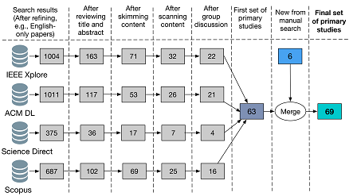
Figure 1: Overview of the search and selection steps
SYSTEM REQUIREMENTS

Hardware Requirements:

Processor - Pentium –IV
- Speed - 1.1 GHz
- Ram - 256 MB
- Hard Disk - 20 GB
- Key Board - Standard Windows Keyboard
- Mouse - Two or Three Button Mouse
- Monitor - SVGA
Software Requirements:
- Operating System - Windows XP
- Coding Language - Java

